
FACT SHEET
ACT Parliamentary Counsel’s Office

TOPIC: PCO’s editorial renumbering publishing practice

- The Legislation Act 2001, part 11.3 authorises the Parliamentary Counsel to make editorial amendments and other changes of a formal nature when preparing a law for republication, including changes that are consequential on any amendment made to the law by another law.
See section 116 of the Legislation Act.

- It is PCO’s publishing practice to renumber provisions below section level to update the numerical or alphabetical sequence consequential on an amendment made to the law by another law.
For example:
1 If an amendment omits subsection (2) from a series of 4 subsections (subsections (1) to (4)), subsections (3) and (4) may be renumbered as subsections (2) and (3).
2 If an amendment adds a new subsection (3A) to a series of 5 subsections (subsections (1) to (5)), the new subsection and subsections (4) and (5) may be renumbered as subsections (4), (5), and (6).
3 If an amendment omits paragraph (b) from a series of 4 paragraphs (paragraphs (a) to (d)), paragraphs (c) and (d) may be renumbered as paragraphs (b) and (c).
4 If an amendment adds a new paragraph (aa) to a series of 3 paragraphs (paragraphs (a) to (c)), the paragraphs may be renumbered as paragraphs (a), (b), (c) and (d).

- There is a statement on the inside front cover of each version of a law indicating whether editorial amendments have been made.
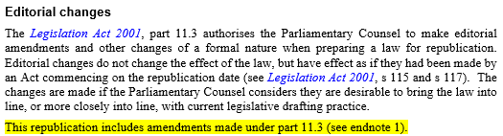

- Additionally, the amendment history in the endnotes of a law is annotated to show that the section has been amended by a particular law (for example, A2013-30 highlighted below), that the subsections, paragraphs or subparagraphs have been renumbered under the Legislation Act, and in which republication this has been done.
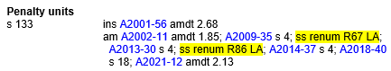

Version 1 – 15/02/2022

